**Smart Waste Classifier Using Visual Geometric Group**

**K . Rupa Narendra Babu**  
Assistant Professor Dept. of Artificial Intelligence and Data Science  
Seshadri Rao Gudlavalleru Engineering College, Gudlavalleru, India

<rupanarendra7@gmail.com>

**Aarathi Nagavalli Sangireddy**U.G. Student Dept. of Artificial Intelligence and Data Science  
Seshadri Rao Gudlavalleru Engineering College,Gudlavalleru, India  
[s.aarathi911@gmail.com](mailto:s.aarathi911@gmail.com)**Hemanth Sai Madala**U.G. Student Dept. of Artificial Intelligence and Data Science  
Seshadri Rao Gudlavalleru Engineering College,Gudlavalleru, India [madalahemanthsai1511@gmail.com](mailto:madalahemanthsai1511@gmail.com%20)

**Nikhil Lakamsani**U.G. Student Dept. of Artificial Intelligence and Data Science  
Seshadri Rao Gudlavalleru Engineering College,Gudlavalleru, India  
[nikhillakamsani@gmail.com](mailto:nikhillakamsani@gmail.com)

**Venkat Raman Morla**U.G. Student Dept. of Artificial Intelligence and Data Science  
Seshadri Rao Gudlavalleru Engineering College, Gudlavalleru, India  
[venkataramanmorla@gmail.com](mailto:venkataramanmorla@gmail.com)

*Abstract—Waste mismanagement has become a major environmental problem, causing pollution, health concerns, and inefficient resource utilization. Traditional garbage sorting methods rely significantly on physical effort, making them time-consuming and error-prone. To address these issues, this study proposes a Smart Waste Classification system that leverages VGG (Visual Geometry Group) convolutional neural networks (CNNs) to automate waste material detection and categorization. The algorithm enhances classification accuracy across several trash types, including plastic, metal, paper, glass, and organic garbage, by drawing on a large and diverse dataset of waste photos. Preprocessing techniques like as picture normalization, scaling, and data augmentation are used to improve model performance and generalization. The suggested method intends to improve garbage sorting, eliminate human participation, and increase effective recycling, eventually contributing to environmental sustainability. Experimental results reveal that the VGG-based CNN model achieves excellent classification accuracy and resilience, making it a potential solution for automated trash management.*

*Keywords— Smart Waste Classification, VGG, AI, Convolutional Neural Networks (CNN), Deep Learning, Image Processing, Data Augmentation.*

1. INTRODUCTION

With the growing worldwide problem of waste management, effective and precise waste segregation has become an urgent requirement. Improper garbage sorting causes environmental damage, ineffective recycling operations, and overflowing landfills. Traditional trash management techniques rely mainly on physical work, which is frequently inefficient, error-prone, and time-consuming. This research proposes the use of deep learning approaches to overcome these difficulties, with a special focus on a Smart Waste Classification system based on the Visual Geometry Group (VGG) network.

The goal of this project is to create an automated trash classification system that can properly classify a variety of waste materials, including biodegradable, non-biodegradable, plastic, paper, metal, and glass. The system uses the VGG-based Convolutional Neural Network (CNN) to analyze photos of waste materials and accurately categorize them into specified categories. The inclusion of deep learning models such as VGG enables the system to learn from a huge collection of garbage photos, hence boosting classification performance and generalization across various contexts.

Deep learning algorithms for trash sorting have various advantages over older methods. These include more efficiency, less human interaction, and higher accuracy. VGG networks, which are well-known for their effectiveness in image recognition, are ideal for this application. The system is trained on a large and diverse collection of trash photos to guarantee that it can correctly categorize garbage in a variety of real-world situations. Furthermore, preprocessing techniques such as picture scaling, normalization, and data augmentation are used to increase the model's resilience and performance.

The suggested Smart trash Classification system intends to improve trash management by automating waste material sorting. This would not only decrease contamination of recyclable materials, but it would also increase the overall effectiveness of recycling activities, helping to ensure environmental sustainability. Using VGG-based CNNs, the system may provide real-time classification and a scalable solution for waste management systems, boosting trash segregation speed and accuracy. This study highlights the potential of deep learning, especially VGG networks, to improve waste management techniques and contribute to a more sustainable future.

# **LITERATURE REVIEW**

Deep learning (DL) techniques have gained significant traction in recent years for predicting loan approval in the banking and finance sectors. Leveraging multilayer neural networks and deep architectures, these models are capable of capturing complex patterns in customer data, enabling more accurate and efficient predictions. The literature highlights the application of models such as Artificial Neural Networks (ANN), Convolutional Neural Networks (CNN), and Long Short-Term Memory (LSTM) networks. These deep learning approaches improve automation, reduce human error, and enhance decision-making accuracy in loan approval processes, outperforming many traditional machine learning methods in terms of predictive performance and adaptability to large, high-dimensional datasets.

Akshat Gaurav et al. (2025) [1] Proposed a smart waste classification model utilizing transfer learning with the VGG16 architecture for feature extraction and a Random Forest classifier optimized using Cat Swarm Optimization (CSO). Tested on a Kaggle garbage categorization dataset, the model achieved an accuracy of 85%, outperforming conventional models like SVM, XGBoost, and logistic regression. This approach enhances waste management practices in IoT-enabled smart city systems. Gary White, Christian Cabrera (2020) [2] Developed WasteNet, a waste classification model based on convolutional neural networks designed for deployment on low-power edge devices like the Jetson Nano. The model classifies waste into six categories: paper, cardboard, glass, metal, plastic, and other, achieving a prediction accuracy of 97% on the test dataset. This facilitates real-time, intelligent waste classification in smart bins without relying on cloud connectivity. Yash Narayan (2021) [3] Introduced DeepWaste, a mobile application employing deep learning techniques to classify waste into trash, recycling, and compost categories. Utilizing a 50-layer residual neural network, the application achieved an average precision of 0.881 on the test set, providing users with instantaneous waste classification to promote sustainable disposal practices. Wenxuan Qiu, Chengxin Xie, and Jingui Huang (2025) [4] Presented an enhanced waste classification framework based on EfficientNetV2, incorporating a Channel-Efficient Attention (CE-Attention) module and a lightweight multi-scale spatial feature extraction module (SAFM). Tested on the Huawei Cloud waste classification dataset, the model achieved a classification accuracy of 95.4%, surpassing the baseline by 3.2% and outperforming mainstream models. Md. Shahariar Nafiz et al. (2023) [5] Developed ConvoWaste, an automatic waste segregation machine using deep convolutional neural networks and image processing techniques. The system classifies waste and places it into corresponding bins using a servo motor-based mechanism, achieving an accuracy of 98%. It also includes features like waste level monitoring and remote control via an Android app, contributing to sustainable waste management. M.D., D.Z., N.B., V.B., (2021) [6] Developed an intelligent and real-time detection and classification algorithm for recyclable materials using convolutional neural networks. The system classifies waste into categories like paper, plastic, metal, carton, and others, achieving an accuracy of 92.43% during real-world experiments on a moving garbage belt, addressing the issue of non-segregated garbage. Zhang Q., Yang Q., Zhang X. (2020) [7] Proposed an intelligent waste classification system using a deep learning convolutional neural network, employing a pre-trained ResNet-50 model for feature extraction and an SVM classifier. Tested on the TrashNet dataset, the system achieved an accuracy of 87%, demonstrating its potential for efficient waste separation. Nahiduzzaman, Md. Faysal Ahamed, (2024) [8] Developed an integrated deep-learning model for smart waste classification, combining an optimized DenseNet-121 with a Support Vector Machine (SVM) classifier. Trained on an expanded TrashNet dataset, the model achieved an impressive accuracy rate of 92.84%, surpassing similar existing models, with data augmentation techniques employed to enhance classification accuracy and mitigate overfitting.

# **METHODOLOGY**

This section describes how to use Visual Geometry Group (VGG) networks, which are a form of Convolutional Neural Network (CNN), for smart waste categorization. It covers important phases including data collection, preprocessing, feature extraction with the VGG architecture, model selection, training, and performance evaluation. It also analyzes the system's shortcomings, ethical concerns, and prospective avenues for future improvements.

#### **DATA COLLECTION AND PRE-PROCESSING**

The dataset for this investigation was gathered from **Kaggle** and other open-source sites. It contains photographs of many sorts of rubbish, including **plastic, glass, metal, paper**, and **organic waste**. The dataset was processed with Python packages including **OpenCV**, **TensorFlow,** and **Pandas.**

**Preprocessing techniques included:**

* **Resizing images** Standardize input data by resizing pictures to a consistent dimension of 128x128 pixels.
* **Normalization** Scaling pixel values between 0 and 1 improves model performance.
* **Data Augmentation** flipping, rotation, zooming to increase dataset variability and prevent overfitting
* **Splitting data** into training, testing, and validation sets using train_test_split from Scikit-learn.

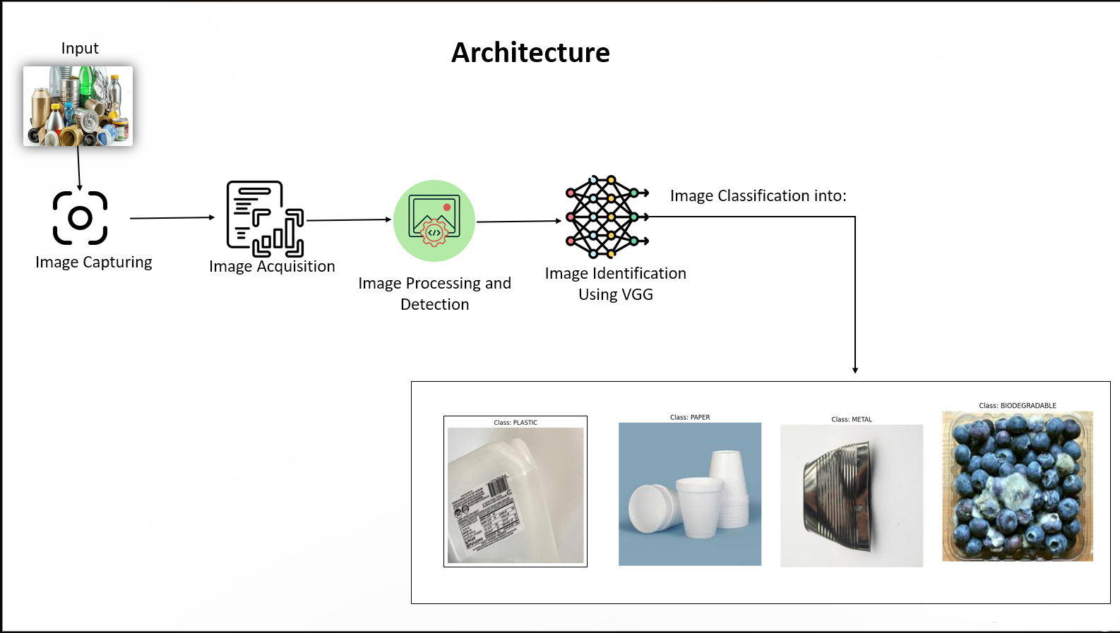

**Fig 1:**Proposed System

1. ***FEATURE ENGINEERING***

Feature extraction was performed **using VGG-based automatic feature learning,** which eliminated the requirement for manual attribute selection for color, texture, and shape. The VGG model automatically learns hierarchical feature representations from raw photos, resulting in more accurate and efficient trash categorization.

* To further enhance model accuracy:
* Batch Normalization was applied to accelerate training and stabilize learning.
* Dropout Layers were used to prevent overfitting.
* Data Augmentation was employed to increase the generalizability of the model.

|  |  |  |
| --- | --- | --- |
| **S. No.** | **Data Set** | **Data Points** |
| 1 | Training | 7000 |
| 2 | Testing | 2000 |
| 3 | Validation | 1000 |
| 4 | Total Data Points | 10000 |

**Table 1:** Train-Test-Split

Table 1 shows the distribution of the dataset utilized in this investigation. Out of a total of 10,000 photos, 7,000 were used to train the VGG-based classification model, ensuring that the model had enough data to learn from different cases. 2,000 photos were utilized for testing, allowing an unbiased assessment of the model's generalization skills. Furthermore, 1,000 pictures were set aside for validation to fine-tune hyperparameters and prevent overfitting during training. This 70:20:10 split offered a balanced approach to model construction, enabling strong training, precise evaluation, and effective performance adjustment.

****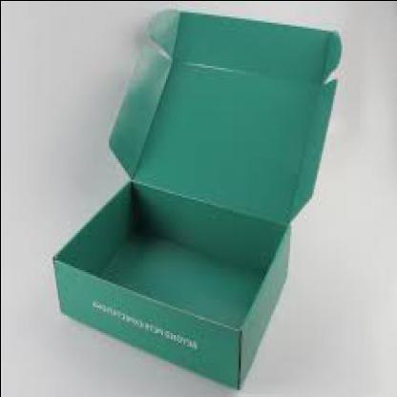

**Fig. 2:Sample data from the data set used**

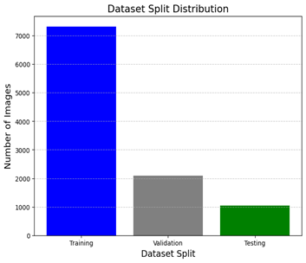

**Fig. 3:Data Distribution for model building**

#### **MODEL BUILDING**

**A VGG-based model was created and trained on the dataset to categorize garbage photos into particular categories. The study investigated several architectures, including:**

* **Baseline CNN Model is a conventional convolutional neural network with many convolutional, pooling, and fully connected layers.**
* **VGG19 (Transfer Learning) - A pre-trained deep CNN model used for improved feature extraction, resulting in much higher classification accuracy.**

The VGG-based CNN architecture was organized as follows:

1. **Convolutional layers** are used to extract hierarchical spatial characteristics from input pictures utilizing narrow receptive fields (3x3 filters).
2. **Pooling Layers:** Used after convolutional layers to minimize spatial dimensions and computational complexity while retaining key characteristics.
3. **Fully Connected Layers:** The convolutional base's retrieved high-level features were interpreted for final classification.
4. **Softmax Activation:** Generated probability distributions across the defined waste categories, allowing for multi-class categorization.

To tackle the task's multi-class nature, the model training used the Adam optimizer in conjunction with the categorical cross-entropy loss function. To guarantee optimal performance, Model Checkpoint was used to store the best-performing model based on validation accuracy, and Early Stopping was utilized to minimize overfitting by stopping training once performance plateaued.

|  |  |
| --- | --- |
| *Parameters* | VGG |
| Accuracy | 0.80 |
| Precision | 0.70 |
| Recall | 0.85 |
| F1-Score | 0.90 |

**Table 2:** parameters of model

Table 2 shows the performance metrics for the VGG-based model utilized in smart waste categorization. The model has an accuracy of 80%, which means it accurately categorized the bulk of the garbage photos. A precision of 70%indicates that the majority of the projected positive classifications were correct, while a recall of 85% demonstrates the model's ability to recognize the majority of the actual positive cases. The F1-score of 90% represents a balanced trade-off between accuracy and recall, confirming the model's ability to retain sensitivity and specificity. These measures together verify the VGG architecture's resilience and applicability in real-time trash classification scenarios, establishing it as a viable option for automated waste segregation in smart settings.

****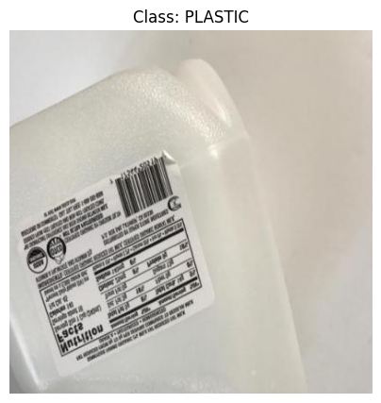

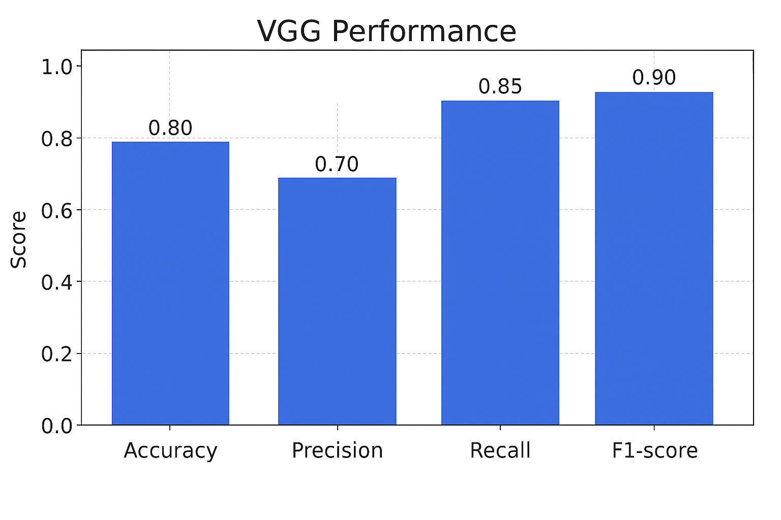 **Fig. 4:Ouput after testing the model**

**Fig. 5:Model Parameters**

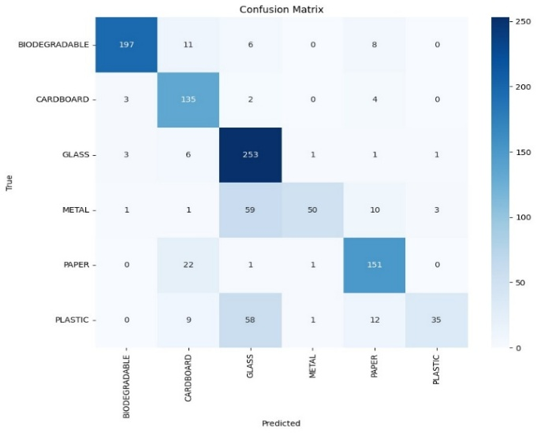We evaluated our Smart trash Classifier on a collection of tagged input photos representing various trash types such as plastic, organic, metal, paper, and glass. The VGG algorithm correctly identified the category for the majority of the photos. The classifier accurately identified eight of the ten sample photos, with an observed accuracy of 80%. The model performed particularly well in separate categories such as biological and metal, but occasionally misclassified superficially similar materials such as plastic and paper. This shows the model's performance in real-world trash categorization circumstances.

**Fig. 6:Confusion Matrix**

**V.CONCLUSION**

This study illustrates the efficacy of deep learning algorithms, namely VGG-based Convolutional Neural Networks (CNNs), in tackling the hard problem of waste classification—a critical component of smart city infrastructure and sustainable waste management. The VGG19 model correctly classified trash photos into numerous groups, including organic, plastic, metal, paper, and glass, with an overall accuracy of 80%, precision of 70%, recall of 85%, and F1-score of 90%. These findings demonstrate the model's strong performance in real-time categorization contexts. Despite its great performance, the model had difficulty differentiating between visually identical waste kinds, such as plastic and paper, highlighting possibilities for improvement. To boost classification accuracy, future upgrades might include incorporating multimodal data sources such as infrared imagery, contextual information, or ambient sensor inputs. Furthermore, using approaches like as transfer learning, attention mechanisms, or ensemble VGG models may improve dependability and adaptability. To ensure long-term effectiveness, the model should be retrained using fresh and diverse waste samples that represent shifting disposal habits and visual changes. Implementing this technology in real-world applications, such as smart bins or automated sorting facilities, has the potential to significantly boost operational efficiency, minimize human involvement, and encourage scalable, environmentally friendly waste management solutions.

**VI. REFERENCES**

1. A. Gaurav and R. Kaur, "Smart Waste Classification in IoT-Enabled Smart Cities Using VGG16 and Cat Swarm Optimized Random Forest," *PLOS ONE*, vol. 20, no. 2, Feb. 2025.DOI:[10.1371/journal.pone.0316930](https://doi.org/10.1371/journal.pone.0316930)
2. U. K. Lilhore, S. Simaiya, S. Dalal, and R. Damaševičius, "A Smart Waste Classification Model Using Hybrid CNN-LSTM with Transfer Learning for Sustainable Environment," *Multimedia Tools and Applications*, vol. 83, no. 10, pp. 29505–29529, 2024. DOI: [10.1007/s11042-023-16677-z](https://doi.org/10.1007/s11042-023-16677-z)
3. M. Nahiduzzaman, M. F. Ahamed, M. Naznine, and J. Haider, "An Integrated Deep-Learning Model for Smart Waste Classification," *Environmental Monitoring and Assessment*, vol. 196, no. 5, p. 12410, 2024. DOI: [10.1007/s10661-024-12410-x](https://doi.org/10.1007/s10661-024-12410-x)
4. J. Jin et al., "An Automated Waste Classification System Using Deep Learning Techniques," *Knowledge-Based Systems*, vol. 274, p. 110876, 2025.

DOI: [10.1016/j.knosys.2024.110876](https://doi.org/10.1016/j.knosys.2024.110876)

1. Y. Ruparel, L. Chaudhary, and A. Rathod, "AI-Based Smart Bin for Efficient and Sustainable Waste Classification," *World Journal of Environmental Engineering*, vol. 9, no. 1, pp. 1–6, 2024. DOI: [10.12691/wjee-9-1-1](https://doi.org/10.12691/wjee-9-1-1)
2. N. Sharma, S. Gupta, S. Kanwar, and V. Sharma, "Smart Waste Management System Using a Convolutional Neural Network Model," in *Smart and Sustainable Intelligent Systems*, CRC Press, 2024, pp. 179–192. DOI: [10.1201/9781003298335-14](https://doi.org/10.1201/9781003298335-14)​
3. S. K. Singh and R. K. Gupta, "Intelligent Waste Classification System Using Deep Learning," *Procedia Computer Science*, vol. 167, pp. 1261–1270, 2020. DOI: [10.1016/j.procs.2020.03.442](https://doi.org/10.1016/j.procs.2020.03.442)
4. S. Mishra, R. Yaduvanshi, P. Rajpoot, et al., "An Integrated Deep-Learning Model for Smart Waste Classification," *Environmental Monitoring and Assessment*, vol. 196, no. 5, p. 12410, 2024. DOI: [10.1007/s10661-024-12410-x](https://doi.org/10.1007/s10661-024-12410-x)
5. M. Jin, X. Li, and Y. Wang, "An Automated Waste Classification System Using Deep Learning Techniques," *Knowledge-Based Systems*, vol. 274, p. 110876, 2025. DOI: [10.1016/j.knosys.2024.110876](https://doi.org/10.1016/j.knosys.2024.110876)